Task 1:
Actuators – are the spring boot features that helps to monitor and manage the application. It gives api endpoints to check applications health, metrics, logs etc.

Task 2:
Advantages of actuators:
- Monitor application health
- Get application metrics
- Display information and environment details
- Helps in debugging and troubleshooting

Task 3:
Commonly used actuator:
- /health – to show health
- /info – to show information
- /metrics – to show metrics
- /env – to show environment details
- /mappings – to show request mappings

Task 4:
Pom.xml:
<dependency>
<groupId>org.springframework.boot</groupId>
<artifactId>spring-boot-starter-actuator</artifactId>
</dependency>

Application.properties:
management.endpoints.web.exposure.include=*

localhost:8080/actuator/health:
{
"groups": [
"liveness",
"readiness"
],
"status": "UP"
}

Task 5:
Spring Security Architecture - is a framework that provides authentication and authorization. It protects web applications from unauthorized access and common security attacks.

Task 6:
- Security Filter Chain – Intercepts every request.
- Authentication Manager – Verifies user credentials.
- Authentication Provider – Performs the actual authentication.
- UserDetailsService – Loads user details from the database or memory.
- Password Encoder – Encrypts and verifies passwords.
- Security Context – Stores details of the authenticated user.

Task 7:
Spring security architecture diagram:

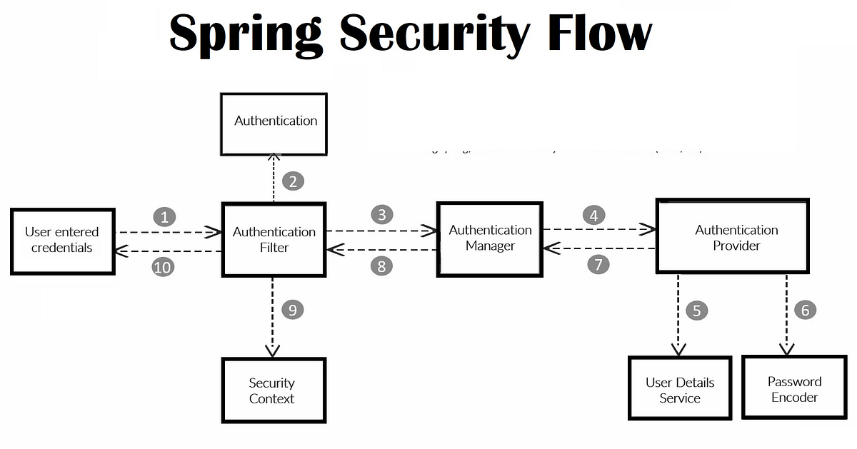

Task 8:
Security Filter Chain - is a collection of filters that intercept every HTTP request before it reaches the controller. It performs tasks like authentication, authorization, and session management.

Task 9:
AuthenticationManager - verifies the user's username and password and decides whether the user is authenticated.
@Autowired
AuthenticationManager authenticationManager;
Authentication authentication =
authenticationManager.authenticate(
new UsernamePasswordAuthenticationToken("admin", "password")
);

Task 10:
AuthenticationProvider - performs the actual authentication. It checks the user's credentials against a database.
@Bean
public AuthenticationProvider authenticationProvider() {

DaoAuthenticationProvider provider = new DaoAuthenticationProvider();
provider.setUserDetailsService(userDetailsService());
provider.setPasswordEncoder(passwordEncoder());

return provider;
}

Task 11:
UserDetailsService - is an interface that loads user information from a database.
@Service
public class MyUserDetailsService implements UserDetailsService {

@Override
public UserDetails loadUserByUsername(String username) {

return User
.withUsername("admin")
.password("$2a$10...")
.roles("ADMIN")
.build();
}
}

Task 12:
PasswordEncoder - encrypts passwords before storing them and compares encrypted passwords during login.

Bean:
@Bean
public PasswordEncoder passwordEncoder() {
return new BCryptPasswordEncoder();
}

Encoding a string:
String encoded = passwordEncoder.encode("password123");

Task 13:
SecurityContextHolder - stores the details of the currently authenticated user during a request. It allows us to access the logged-in user's details anywhere in the application.

Task 14:
Internal workflow of spring security architecture:
- Client sends a request.
- The Security Filter Chain intercepts the request.
- Username and password are extracted.
- The Authentication Manager receives the credentials.
- It forwards them to the Authentication Provider.
- The Authentication Provider calls the UserDetailsService.
- UserDetailsService loads the user's details from the database.
- The Password Encoder compares the entered password with the stored encrypted password.
- If authentication is successful, user details are stored in the SecurityContextHolder.
- Spring checks whether the user has authorization to access the requested resource.
- If authorized, the request reaches the Controller.
- The Controller processes the request and returns the response.
- If authentication or authorization fails, Spring returns 401 Unauthorized or 403 Forbidden.

Task 15:
Thymeleaf - is a Java template engine used in Spring Boot to create dynamic web pages. It works as the View in the Spring MVC architecture. It receives data from the Controller and displays it in HTML pages. It is used to create dynamic HTML pages and display data from the backend.

Task 16:
Thymleaf demo:
Pom.xml:
<dependency>
<groupId>org.springframework.boot</groupId>
<artifactId>spring-boot-starter-thymeleaf</artifactId>
</dependency>

Demo controller (ProductController.java):
package com.thymleafdemo;

import java.util.List;

import org.springframework.stereotype.Controller;
import org.springframework.ui.Model;
import org.springframework.web.bind.annotation.GetMapping;

@Controller
public class ProductController {

@GetMapping("/products")
public String getProducts(Model model) {

List<String> products = List.of(
"Laptop",
"Mobile",
"Keyboard",
"Mouse"
);

model.addAttribute("products", products);

return "products";
}
}

Demo html template (product.html):
<!DOCTYPE html>
<html xmlns:th="http://www.thymeleaf.org">
<head>
<title>Products</title>
</head>
<body>

<h1>Product List</h1>

<ul>
<li th:each="product : ${products}"
th:text="${product}">
</li>
</ul>

</body>
</html>

Task 17:
Advantages of Thymleaf:
- Easy integrates with Spring Boot.
- Creates dynamic HTML pages.
- Supports conditions, loops, and expressions.
- Produces clean and maintainable code.
- Good support for form handling.

Task 18:
Caching is a technique used to store frequently accessed data in memory so that future requests can be served faster without repeatedly fetching data from the database or performing expensive calculations.

Task 19:
Features of Spring Boot caching:
- Improves Performance: Serves data from cache instead of repeatedly executing costly operations.
- Reduces Database Calls: Minimizes unnecessary database queries for frequently accessed data.
- Annotation-Based Caching: Simple implementation using @Cacheable, @CachePut, and @CacheEvict.
- Supports Multiple Cache Providers: Works with Redis, Caffeine etc.
- Custom and Conditional Caching: Supports custom cache keys and caching based on specific conditions.

Task 20:
Types of caching:
- In-Memory Cache – Stores data in the application's RAM for very fast access.
- Distributed Cache – Stores data in a shared cache that can be accessed by multiple application instances.
- Disk Cache – Stores cached data on the hard disk, providing larger storage but slower access than memory.
- Database Cache – Stores frequently accessed database query results to reduce database load and improve performance.

Task 21:
Annotations used for caching:
- @EnableCaching - Enables caching in the application.
- @Cacheable - Stores method results in the cache.
- @CachePut - Updates the cache after method execution.
- @CacheEvict - Removes entries from the cache.
- @Caching - Combines multiple caching operations on a single method.

Task 22:
@InjectMocks - creates an instance of the class being tested and automatically injects all the @Mock or @Spy objects into it. This saves us from manually creating the object and passing its dependencies.

Task 23:
@Spy creates a partial mock. It uses the real object and real methods by default, but you can mock specific methods if needed.
Demo code from previous bank service, to test whether account is real or not:

package com.mockitotest;

import static org.junit.jupiter.api.Assertions.assertEquals;
import static org.mockito.Mockito.*;

import org.junit.jupiter.api.Test;
import org.junit.jupiter.api.extension.ExtendWith;
import org.mockito.Mock;
import org.mockito.Spy;
import org.mockito.junit.jupiter.MockitoExtension;

@ExtendWith(MockitoExtension.class)
class BankServiceTest {

@Mock
private BankRepository mockRepo;

@Spy
private BankAccount account = new BankAccount("123", 500.0);

@Test
void testDeposit() {

when(mockRepo.findByAccountNumber("123"))
.thenReturn(account);

BankService service = new BankService(mockRepo);

service.deposit("123", 200.0);

assertEquals(700.0, account.getBalance());

verify(account).deposit(200.0); // Spy verification
verify(mockRepo).save(account);
}
}

Task 24:
@Mock - is used to create a fake object of a class or interface for unit testing. It avoids calling the real implementation to make tests faster and independent of databases.

Task 25:
Partial mocking is when some methods implementations are real and some others are mocked. It is achieved by @Spy annotation.

Task 26:
verify () - checks whether a particular method on a mock object was called during the test. It returns true if the method was called and if never () is used with it, it returns false if method was called.

Task 27:
Annotations used in mocking:
- @Mock – used to mock methods and interfaces.
- @injectMock – used to inject @Mock and @Spy objects into instance of class created.
- @Spy – to implement partial mock.
- @ExtendWith (MockitoExtension.class) - enable Mockito in JUnit 5.
- @MockitoSettings – Configures Mockito behaviour for test classes.
- @MockBean – Replaces a Spring bean with a mock in the application context during tests.

